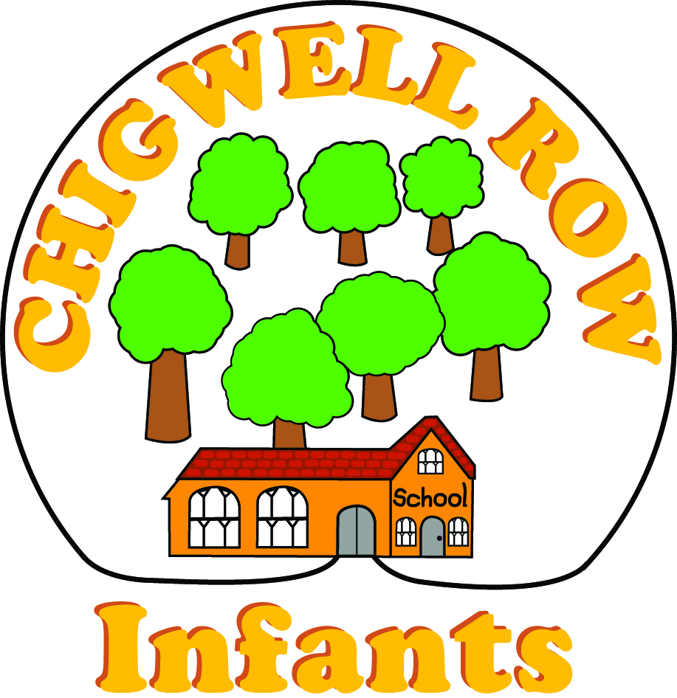
Assessment & Feedback Policy

Rationale
Marking children’s work forms an important part of the assessment, feedback & planning process. It has two purposes; firstly to provide feedback to the child & secondly to provide an assessment record. It is a powerful tool for giving support to children’s learning. It gives the teacher opportunity to inform children of their success, giving them advice on how they might improve their work & suggestions on how to overcome weaknesses. It is a manageable way of informing planning & recording achievement.

Our policy for assessment & feedback:
- Recognises that marking’s an essential part of planning & assessing teaching & learning.
- Ensures the purpose of marking is to assist learning.
- Promotes high standards & positive attitudes to learning & behaviour.
- Ensures a consistent approach to marking throughout the school.
- Values work & gives recognition & praise for achievement.
- Provides constructive feedback & clear strategies for improving learning.
- Corrects mistakes, addresses misunderstandings & offers encouragement.
- Provides assessment information & informs future planning.
- Enables pupils to reflect on their past performances & set new targets together with the teacher.
- Immediate feedback during the lesson is more effective than feedback given later. Pupils have opportunity, either at the time or during the next lesson to reflect & respond to feedback which has been given.
- Provides ongoing opportunities for self assessment.
- Teaches children to recognise what they do well.
- Fosters a culture whereby it is okay to make mistakes but good to learn from them.
- Ensures marking is regular & frequent.
- Encourages pupils to accept help/guidance from others.

Guidelines
In EYFS:
- There will be appropriate use of symbols to aid assessment/displays of writing skills (see below)
- There will be verbal discussion of work which will be recorded in some way.

In Key Stage 1:
- The Early Years practice will be continued & built upon.
- As children develop there will be a greater emphasis on the children’s response.
- Once a week, for maths & English child should have developmental marking with an opportunity to respond to next steps in purple pen.
- Writing in black will be for teacher’s & other adults’ assessment notes which for Mathematics should include resources & strategies used e.g. known facts, counting on, using fingers, in head, knowledge of inverse.
- Supply teachers will be asked to use black & indicate the level of support provided.

Marking System
These symbols & colour codes will be used across the school & communicated to children:
- Pink indicates children’s successes (Pink smiley face)
- Green indicates children’s next steps (green steps)
- Purple indicates when a child has responded to feedback & next steps

Work will be annotated to show the amount of support given & the annotation followed by the initials of the supporting adult where this is not the Class Teacher:
- I – Independent
- WS – With Support
- WFS – With Full Support
- VF – Verbal Feedback

Effective Marking in Key Stage 1
Feedback is likely to have most impact when it is immediate, although this is not always possible. It is important to plan when & how feedback will be given. If a 'next step' has been given teachers need to provide time for children to follow it up in purple pen Children should be encouraged to reflect on their own writing & begin to make improvements to their work. This is the beginning of self-assessment. Children need to be able to monitor & assess their work both during & after writing. During writing children need to read & re-read sentences & sections of the text aloud, thinking about the meaning & the language they are using. (e.g. ‘Does this make sense?’ ‘Could I use a better word?’). After writing children should be encouraged to reflect on the success criteria to determine how well they have met the learning intention.

Teacher marking expectation for Maths in year 1 & 2:
Daily Marking
Each day by teacher or LSA, children's work should be marked off against the success criteria they have followed. A pink tick/smiley should be placed by each correct step. If a child has missed a step or carried out a step inaccurately, a green pen should be used to highlight & feedback given verbally (VF) or written briefly.
Example:

LO: Add by partitioning
I partition the tens & ones 
I add the tens together
I add the ones together
I recombine the tens & the ones make sure you don't forget this step or (VF)

Developmental marking (at least once a week)
Each week children should have the opportunity extend & develop their maths skills & whenever possible, these should take the form of problem solving, challenges & 'maths mastery' activities. These can be practical activities, pictorial or abstract. Teachers should be careful when giving next steps & be sure that the next step or challenge relates specifically to the learning intention of the lesson or the topic that children have been learning. Always refer to learning achieved before next step.
Examples:
You can add two digits to 2 digits
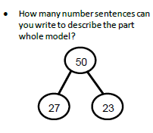

You understand place value of tens & ones

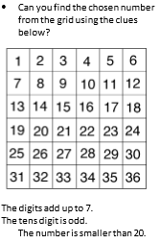

Teachers can find examples of these maths challenges specifically matched to learning intentions for each stage of development on:
- The White Rose Maths Hub schemes of work for R/Y1/Y2/Y3
- NCTEM website

Teacher marking expectation for English in Year 1 & 2
Daily Marking
Each day by teacher or LSA, children's work should be marked off against the success criteria they have followed. A pink tick/smiley should be placed by each correct step. If a child has missed a step or carried out a step inaccurately, a green pen should be used to highlight & feedback given verbally (VF) or written briefly.
Example:
LO: Write commas in a list
I choose nouns
I place a comma after each noun
I don’t place a comma before or after the last 'and' Don't place comma before 'and'

Developmental marking (at least twice a week)
Once a week children should have the opportunity extend & develop their writing skills by deepening their understanding of a specific skill, consolidating learning or even stretching imagination! Teachers should be careful when giving next steps & be sure that the next step or challenge relates specifically to the learning intention of the lesson or the topic that children have been learning. Always refer to learning achieved before next step. Children should respond to next steps with purple pen.
Examples:
Well done, you have tried hard to write using adverbs from your word bank
Can you think of 3 adverbs which would describe how someone runs? Can you put them into sentences?
Well done, you have described your setting using adjectives.
Can you write about this setting using adjectives? 
Great. you used lots of conjunctions from your word bank but missed out 'but' & 'when'.
Describe what you did at lunchtime in four sentences, making sure you use 'but & 'when'.

Excellent. You learnt a lot today about past tense verbs.
Can you change these verbs into past tense like this one?
Play – played
Dance - …..........
Walk - …...........
Cry - …...........

Superstar. You understand the rules for adding apostrophes to show possession.
Can you correct this piece of writing for me by re-writing it underneath. Some apostrophes are missing or not being used correctly....
Miss Dowlings class were being very good & did lot's of learning. Miss Dowlings' lesson's are always hard! My best friends favourite lesson is math's. My best lesson is PE because we get to play with bat's & ball's.

You tried hard to use exclamation marks
Try this activity with Mrs T – she will help you to decide if each sentence is a question or an exclamation.
Please stop doing that
Why is it cold today
Can I have a sweet please
Stop thief
Thank you so much, I love it
Why are you talking

Intervention (during the lesson) marking for Maths & English
Intervention marking is most effective during the lesson when children are struggling with a particular concept or 'rule'. Intervention during a lesson might happen when you offer extra practical resources in maths or scaffolded writing activities in literacy. Verbal feedback should be indicated here by (VF) & Green pen should be used to underline where the child has made an error or had a misconception. Black pen should be used by the teacher to comment in children's books. Intervention marking should only be used when necessary & there is no specific requirement on the class teacher to mark a certain amout of books this way. Professional judgement should be used to decide when a child needs intervention marking.
Examples of intervention marking:
- 'Good try – use the number square or minicubes to help you (VF)'
- 'Great. It would be easier if you wrote one digit in each square like this (VF)
- 'You are trying hard to use commas – what is the rule before 'and'? (VF)
- You have some excellent adjectives but have forgotten to add full stops. Please go back & check them.
- Please re-write your last line neatly...
Monitoring & Evaluation
Curriculum co-ordinators will be responsible for monitoring their subject area & will lead staff meeting where work/marking is monitored.
This policy was agreed by staff March 2018
It was agreed by the Governing Body July 2018
It will be reviewed in July 2019

