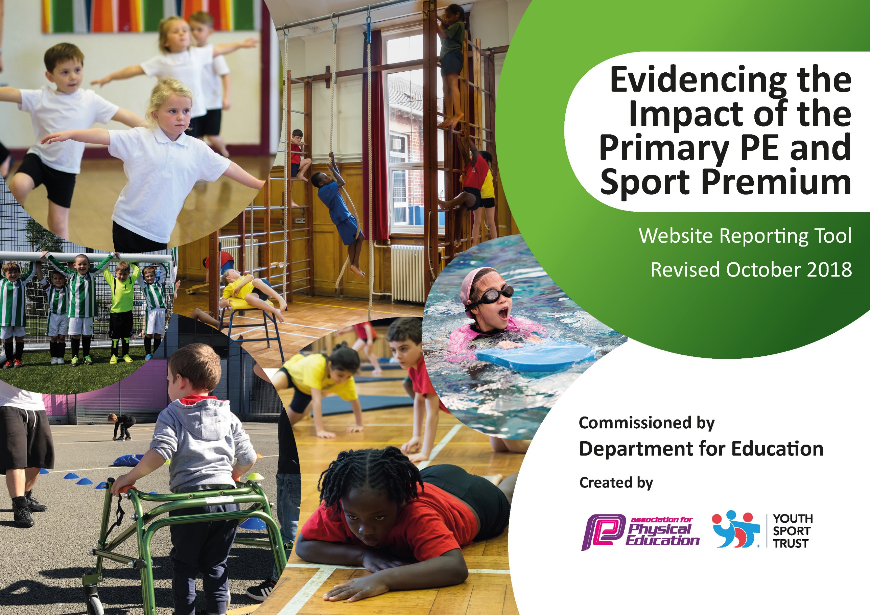
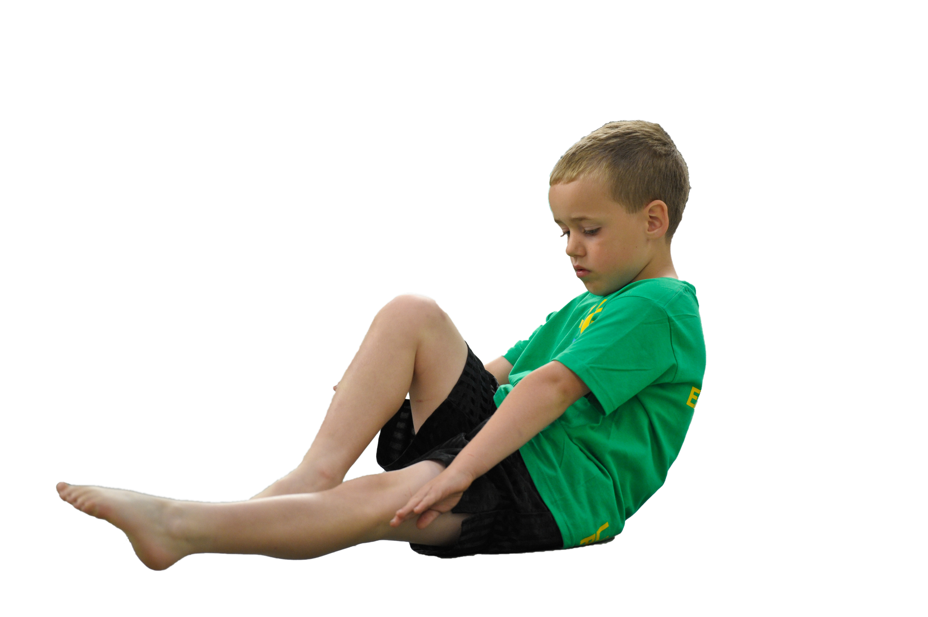
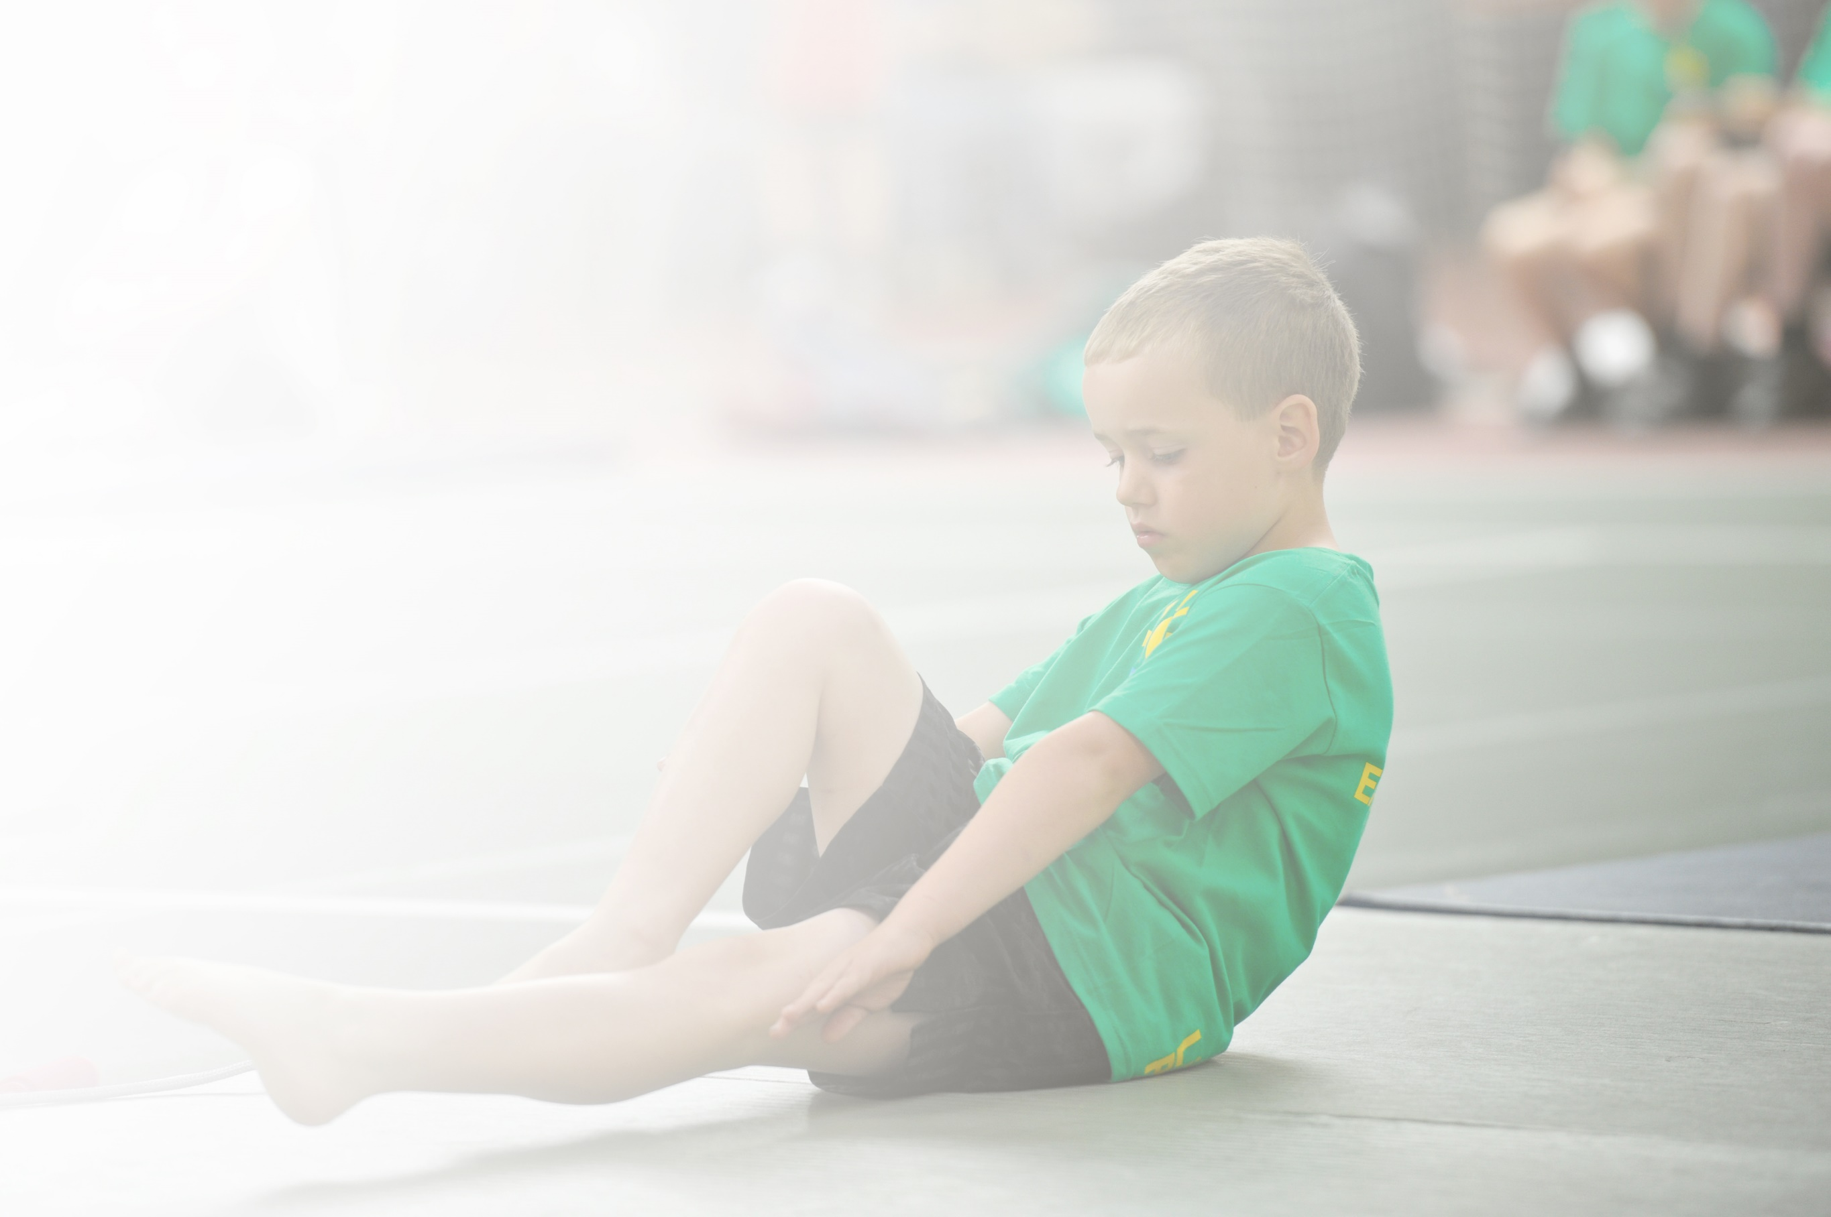
Schools must use the funding to make additional and sustainable improvements to the quality of Physical Education, Sport and Physical Activity (PESPA) they offer. This means that you should use the Primary PE and Sport Premium to:

- Develop or add to the PESPA activities that your school already offer
- Build capacity and capability within the school to ensure that improvements made now will benefit pupils joining the school in future years

Please visit gov.uk for the revised DfE guidance including the 5 key indicators across which schools should demonstrate an improvement. This document will help you to review your provision and to report
your spend. DfE encourages schools to use this template as an effective way of meeting the reporting requirements of the Primary PE and Sport Premium.

We recommend you start by reflecting on the impact of current provision and reviewing the previous
spend. Under the Ofsted Schools Inspection Framework, inspectors will assess how effectively leaders use the Primary PE and Sport Premium and measure its impact on outcomes for pupils, and how effectively governors hold them to account for this.

Schools are required to publish details of how they spend this funding as well as on the impact it has on pupils’ PE and sport participation and attainment by the end of the summer term or by 31 July 2019 at the
latest.
We recommend regularly updating the table and publishing it
on your website throughout the year, as evidence of your
ongoing review into how you are using the money to
secure maximum, sustainable impact. To see an
example of how to complete the table please
click HERE.

Support for review and reflection - considering the 5 key indicators from DfE, what development needs are a priority for your setting and your students now and why? Use the space below to reflect on previous spend, identify current need and priorities for the future.

Key achievements to date: | Areas for further improvement and baseline evidence of need:
- Now offering more varied sports such as football, tag rugby, cricket, swimming, and yoga/relaxation  - Increased involvement in competitive events for all abilities  - Recently re-awarded Healthy Schools Status  - School is a member of the WESSP and receives training from experienced PE leads/teachers  - Pupils receive lessons taught by experienced PE leads/teachers | - Further develop progression in swimming from reception to year 2 by ensuring there is a school wide curriculum map  - Use local sporting sporting personalities (where possible) so pupils can identify with success and aspire to be a local sporting hero  - Organise a disadvantaged pupil multi-sports event to make use of our excellent facilities and encourage these pupils to try sports they made not have tried before  - To ensure pupils learn life saving water skills from an earlier age

Meeting national curriculum requirements for swimming and water safety | Please complete all of the below:
What percentage of your current Year 6 cohort swim competently, confidently and proficiently over a distance of at least 25 metres?  N.B. Even though your children may swim in another year please report on their attainment on leaving  primary school. | N/A
What percentage of your current Year 6 cohort use a range of strokes effectively [for example, front crawl, backstroke and breaststroke]? | N/A
What percentage of your current Year 6 cohort perform safe self-rescue in different water-based situations? | N/A
Schools can choose to use the Primary PE and Sport Premium to provide additional provision for swimming but this must be for activity over and above the national curriculum requirements. Have you used it in this way? | N/A

Action Plan and Budget Tracking
Capture your intended annual spend against the 5 key indicators. Clarify the success criteria and evidence of impact that you intend to measure to evaluate for students today and for the future.

Academic Year: 2021/22 | Total fund allocated: £16000 | Date Updated: 10.4.22
Key indicator 1: The engagement of all pupils in regular physical activity – Chief Medical Officer guidelines recommend that primary school children undertake at least 30 minutes of physical activity a day in school |  |  |  | Percentage of total allocation:
 |  |  |  | 0%
School focus with clarity on intended impact on pupils: | Actions to achieve: | Funding allocated: | Evidence and impact: | Sustainability and suggested next steps:
- Promote the daily mile to ensure ALL pupils undertake at least 15 mins of additional activity per day | - Timetabling 15 mins per day and adhering to it | None | - ALL pupils undertake at least 15 mins of additional activity per day | - Daily mile firmly embedded in the school day
Key indicator 2: The profile of PESSPA being raised across the school as a tool for whole school improvement |  |  |  | Percentage of total allocation:
 |  |  |  | 0%
School focus with clarity on intended impact on pupils: | Actions to achieve: | Funding allocated: | Evidence and impact: | Sustainability and suggested next steps:
- Improve the PE notice board by keeping it current.  - Use local sporting personalities or gifted secondary school or ex-pupils so pupils can identify with success and aspire to be a local sporting hero | - Display TA to work with Sports S/L to update the board regularly  - Put a note in the newsletter, speak to ex-pupils, contact the WESSP group and any other ways to ask for sports people to come in to school | None | - The board is more attractive and informative and pupils are keen to get involved  - The people will inspire the next generation of sporting heroes | - Increased participation in a wide variety of sports

Key indicator 3: Increased confidence, knowledge and skills of all staff in teaching PE and sport |  |  |  |  |  |  |  | Percentage of total allocation:
 |  |  |  |  |  |  |  | 30%
School focus with clarity on intended  impact on pupils: |  |  | Actions to achieve: |  | Funding  allocated: | Evidence and impact: |  | Sustainability and suggested  next steps:
- Sports S/L is a member of the local SSCo who provide regular training for all teacher by experienced specialist teachers  - Use Savvy sports Sports coaches to provide CPD and deliver high quality P.E sessions, including sports for SEND pupils  - Dance through various workshops, to experience a vast variety of dance from different cultures. |  |  | - Continue to subscribe to the WESSP.  Continue to use Savvy Sports. |  | £900  £7520  £1665 | - More staff trained in a variety of sports  - New sports are added to the list offered  - Children and staff learn a variety of different dance techniques from different cultures. |  | - Improved teaching of sport in school and at clubs  - Children have a vast choice of sports to take part in  - Staff learn a variety of new dance techniques, to be able to teach in the future.
Key indicator 4: Broader experience of a range of sports and activities offered to all pupils |  |  |  |  |  |  |  | Percentage of total allocation:
 |  |  |  |  |  |  |  | 1.4%
School focus with clarity on intended  impact on pupils: |  |  | Actions to achieve: |  | Funding  allocated: | Evidence and impact: |  | Sustainability and suggested  next steps:
- Increase the number of sports-based lunch times clubs such as table tennis.  - Provide equipment to allow the children to engage in team games during playtime and lunchtime. |  |  | - Investigate external coaches to run additional clubs such as girls' football  - Buy equipment which gives pupils opportunities to engage in team games during playtime and lunchtime, |  | Unknown  £220 | - More pupils take up sports at lunchtimes and are involved in a wider range of sports |  | - Children take part in a variety of sports at various times of the day
Key indicator 5: Increased participation in competitive sport |  |  |  |  |  |  |  | Percentage of total allocation:
 |  |  |  |  |  |  |  | 9.8%
School focus with clarity on intended  impact on pupils: |  |  | Actions to achieve: |  | Funding  allocated: | Evidence and impact: |  | Sustainability and suggested  next steps:
- Engage more pupils in intra school competitions particularly those classed as disadvantaged  - Provide transport for competitions so financial cost is not a barrier for pupils to partake |  |  | - Take part in more competitions organised by WESSP ensuring disadvantaged pupil take part in multi-sports events and encourage these pupils to try sports they made not have tried before  - Provide free transport for all pupils |  | unknown  £1564 | - Increase the number of disadvantaged pupils taking part competitively in a range of sports |  | - Disadvantaged pupils have every opportunity to partake in sport
 | Other indicator identified by school: Additional swimming and safe self-rescue |  |  |  |  |  |  |  | Percentage of total allocation:
 |  |  |  |  |  |  |  |  | 1.8%
 | School focus with clarity on intended  impact on pupils: | Actions to achieve: |  | Funding  allocated: |  |  | Evidence and impact: |  | Sustainability and suggested  next steps:
 | - Further develop progression in swimming from reception to year 2 by ensuring there is a school wide curriculum map which ensures all pupils can perform self-rescue over a varied distance, so they are safe and confident in the water. | - Sports Subject leader to develop curriculum map  - Ensure all classes have 1 x lessons per week for a term. |  | £300 |  |  | - 100% of pupils can perform safe self-rescue at year 2. |  | - Funding will allow for swimming lessons for all classes from Class R-2 and all pupils will learn to be safe and confident in water from an early age

