Chigwell Row Infant School
SEND Information Report

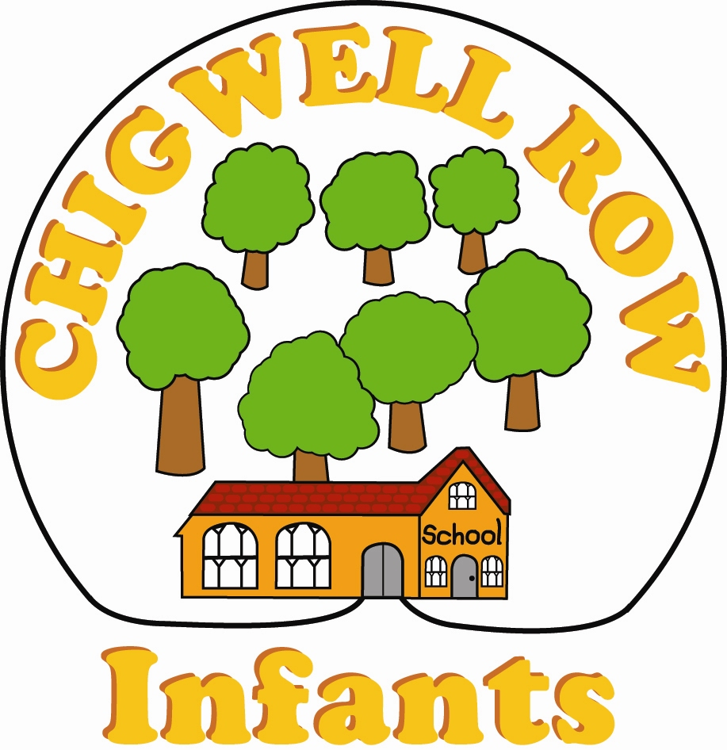o

Special Educational Needs and Disabilities (SEND)
Information Report: November 2020

SENCO: Mrs Rachel Radmore
Cover SENCO (until September 2021): Mrs Lisa Webb (Wednesdays and Fridays)

E-mail: SENCO@chigwellrow.essex.sch.uk

Telephone: 020 8500 3355

Chigwell Row Infant School
45, Lambourne Road,
Chigwell Row
Essex
IG7 6EZ

Address:

Applying for a place at Chigwell Row InfantSchool

All admissions are dealt with by the Local Authority:
Essex County Council
Planning and Admissions, PO Box 4261, Chelmsford, Essex
CM1 1GS
Telephone: 0845 6032200

Subject to current Covid restrictions, parents of all children are welcome to visit the school prior to application. Arrangements can be made to visit the school by appointment with the Headteacher who will be pleased to meet parents and to show them around the school.

Our Ethos
Working closely with parents, governors and the wider community, we provide a caring, secure and happy environment where every child matters and where all children will be nurtured and guided to develop a thirst for learning.

Our School is an inclusive school and offers to meet the needs of all pupils and their families, including those with special educational needs. We have a shared expectation that all pupils, regardless of their special educational needs, should be offered inclusive teaching which will enable them to make the best possible progress in school so they know they are a valued member of the school community. The range of support the school can offer will be arranged for individuals following thorough cycles of ‘assess, plan, do and review’ by internal and/or external agencies.

Aims and Values at Chigwell Row Infant School

We provide a safe, secure, stimulating and happy environment where everybody is respected and valued as an individual.

We encourage children to meet the challenges of life ahead by fostering positive attitudes, self-esteem and confidence.
​
We help our pupils develop self-respect, a sense of responsibility for their own actions and respect for others.

We encourage each child to fulfil his or her potential, to be capable of independent work and to be able to co-operate with others thus developing a life-long enthusiasm for learning.

We provide first-hand experiences which will enhance pupils’ learning.

We help our children develop lively, enquiring minds with the ability to question and argue rationally.

We provide a broad and balanced curriculum which meets the needs of individual pupils.

We create high standards of learning experiences for all children by providing access to all areas of the National Curriculum and Early Learning Goals.

We provide an environment that celebrates individual liberty, diversity, democracy and the rule of law.

An Inclusive School

Our small ‘family-feel’ school places real emphasis on the value of a close link between home and school because this benefits the child both in and outside the classroom. For those children, who for a range of reasons, find it harder to access learning in school, we will, wherever possible, make reasonable adjustments to accommodate individual requirements so that all children, regardless of need, can fully participate in all aspects of school life.

At Chigwell Row Infants we aim to:

● Identify any additional needs of a child as soon as possible and liaise with parents and other agencies where necessary. Where SEND has previously been identified, we will liaise with other establishments.
● Ensure that all staff understand their roles and responsibilities when addressing the needs of a child with SEND so that effective support is provided.
● Ensure that children with SEND access all aspects of the curriculum and that expectations of staff members are high.
● Identify what adjustments can be made within the physical and learning environment to ensure equality of opportunity.
● Provide a supportive, nurturing environment where children’s contributions are valued regardless of additional needs.
● As far as possible, ensure that the curriculum is meaningful and relevant to the child’s needs, differentiating teaching and learning as appropriate.
● Teach with an awareness of different learning styles and use a range of strategies to achieve success.

How accessible is the school environment?
As a school we are happy to discuss individual access requirements. The school is a small and very old building, but current facilities available include:

- Some ramps around the school to make parts of the school accessible.
- An accessible toilet;

Supporting pupils with medical needs
Chigwell Row Infant Schools works closely with medical professionals and families to meet any medical needs identified and which are supported through a care plan. We will liaise with medical professionals and a child’s family to ensure the appropriate support is in place. Children with ongoing medical conditions such as asthma and allergies have their medicine readily available when required. Staff are trained in the use of epi-pens and more specific training is requested when needed.

How do we prepare children joining and leaving our school?
We recognise how important transitions are for children and families and so take a great deal of care planning these. We liaise closely with parents and staff in other settings and where possible visit the child at home or at Nursery/Preschool prior to starting in Reception (Early Years Foundation Stage). We ensure all staff are fully aware of the requirements of Health Care Plans and Education, Health and Care Plans (EHCPs) where necessary.
For children with SEND, transition to Y3 will involve working with the parent and the receiving school to share important information.

How do we include children on activities and school trips?
All trips and outings are planned carefully and risk assessments consider different children’s needs and difficulties.

The Pupil Voice at Chigwell Row Infant School:
Pupils are encouraged to take ownership over their learning. All pupils are involved in developing and evaluating their own learning and considering how they could improve.
They are encouraged to respond to their learning and their teacher’s feedback regularly. The school is continuously working on developing a ‘Growth Mindset’ for learning and children are responding well.
Children that are receiving ‘additional to’ or ‘different from’ provision (this is called SEN Support) are encouraged and enabled (as appropriate) to share their aspirations and these are considered when teachers and parents develop outcomes to work towards, as small steps towards the overall aspirations.

The Parent Voice at Chigwell Row Infant School:
We look to develop a partnership with parents in order to ensure the child’s journey through Chigwell Row Infant School is one of growth and success. We hope that parents will support that partnership. The school holds two parents’ evenings for parents and current Class Teachers to meet.
To keep parents informed we run Parent Partnership meetings or coffee mornings on various topics: starting school, Early Years Foundation Stage, Phonics, Reading, KS1 SATs, homework, Maths, etc. Parents are also invited to special assemblies and celebrations throughout the school year.
We are always ready to speak to parents about any concerns they have about their child or child’s progress. If you have a question or concern that your child may have a particular difficulty with learning, an appointment with the Class Teacher is your first step and an appointment can be made to meet with them through the school office. Your child’s Class Teacher will inform the SENCO to discuss this and if necessary, the concern can be investigated. The SENCO or Head Teacher can also be contacted if there should be an ongoing need or concern.

What do we mean by Special Educational Needs or Disabilities or SEND?
According to the Code of Practice (DfE, 2015) a child or young person has SEND if they have a learning difficulty or disability which calls for special educational provision to be made for him or her.

A child of compulsory school age or a young person has a learning difficulty or disability if he or she: has a significantly greater difficulty in learning than the majority of others of the same age, or has a disability which prevents or hinders him or her from making use of facilities of a kind generally provided for others of the same age in mainstream schools.

The SEND Code of Practice (DfE, 2015) describes four broad categories of SEND. These are:

1. Communication and Interaction

2. Cognition and Learning

3. Social, Emotional and Mental Health

4. Sensory and/or Physical

The code states that: “Many children and young people have difficulties that fit clearly into one of these areas; some have needs that span two or more areas; for others the precise nature of their need may not be clear at the outset.”

The Aims of the Code of Practice 2015: The Code of Practice (2015) aims to improve outcomes by ensuring “high aspirations and expectations for children and young people with SEN.” It states all children and young people are entitled to an education that enables them to make progress so that they:
- Achieve their best
- Become confident individuals living fulfilling lives and
- Make a successful transition into adulthood, whether into employment, further or higher education or training
The school agrees with the aims of the Code of Practice and strives to ensure these are a reality for all children at Chigwell Row Infant School. We especially consider that there is a great importance for children to become independent learners and independent in their life skills development.

The Principles That Guide the School’s Approach to SEND:
The school’s SEND policy and practice sets out:
· To work within the guidance provided by the SEND Code of Practice (DfE 2015)
· To ensure all children are able to enjoy and achieve to their potential.
· To identify and provide for pupils who have additional needs, special educational needs or a disability.
· To see each child as an individual, and work with each child and their family in the approach to agree outcomes and the provision of support for a child’s special educational needs.
· To provide support and advice for all staff working with children who have special educational or additional needs.
· To maintain and develop the partnership and engagement with parents.
· To ensure access to the curriculum for all pupils.

The Graduated Approach to Special Educational Needs or Disabilities:
All children receive high-quality teaching provision at Chigwell Row Infant School. (See next section regarding high-quality teaching.)
Sometimes children can make slower progress than expected or achieve to a standard below that expected for them and it is agreed that ‘temporary additional provision’ or ‘support’ is needed for them to ‘close the gap’ and work within the expected realm of attainment. Some children need some ‘additional support’ through a time of change or difficulty in order to continue making their best progress academically.
Sometimes it is agreed that a child has a ‘special educational need’ (often termed SEN) which impacts on their progress or attainment and requires support that is ‘additional to or different from’ the provision for their peers. This may be shorter or longer term and the provision required will adapt over time according to how the need(s) of the child change. This level of support sometimes involves the advice or input from external specialists, for example Specialist Teachers, an Educational Psychologist or Speech and Language Therapist (SALT). Children at this level of support will also have a ‘One Plan’ (an individual learning support plan) in order to support them in working on their particular area of challenge or difficulty.

The Graduated Approach to Additional or Special Educational Needs

Our SEN register is fluid and regularly reviewed and updated. All pupils that have been receiving support and provision for a temporary ‘additional need’, who have not ‘closed the gap’ in learning after 12 months would then be considered for SEN Support as appropriate. It may be that the learning need might need external professional advice, as could be sought under SEN support. Children that have ‘closed-the-gap’ in learning (if learning was the additional need) would then be supported within the high-quality teaching provision.

Whole Child: Child-Centred Approach
In order to collect the information for a One Plan, a meeting with parents (the one planning meeting will take place once per term). The approach to one planning meetings and the planning and provision is child- and family-centred; their aspirations and learning attitudes are considered, we aim to build on their strengths and successes and ensure the setting of achievable outcomes that are understood by all and reviewed regularly. (The process of ‘child or person-centred reviews’ is referred to in the Local Offer, produced by Essex, as the process of ‘One Planning’, more information is available on their website, link at the end of this document.) The class teacher, LSA and the parent would normally be involved, the child is included where possible /appropriate or their view is sought prior to the meeting and shared. The SENCO is usually involved and the Headteacher is sometimes involved, depending on the level of need of the child.

High-quality Teaching:
The Code of Practice states, and as a school we agree that, high-quality teaching that is differentiated and personalised will meet the individual needs of the majority of children and young people.
At Chigwell Row Infant School, teachers differentiate their planning as appropriate and all children with SEND are carefully considered in lessons and learning. We make use of the Essex ‘Provision Guidance Toolkit’ to support us in ensuring that support is the best it can be.
Staff can access further support from external agencies such as Educational Psychologists or Speech and Language Therapists etc and there is a core training offer for the SENCO, Class Teachers or LSAs.
Some children and young people need educational provision that is additional to, or different from this. This is special educational provision under Section 21 of the Children and Families Act 2014. As a school, we therefore plan for and ensure that such provision is made for those who need it. Special educational provision at Chigwell Row Infant School is shaped around our limited space and staffing resources. The school has very little space for group interventions away from classrooms. Staffing is also limited for these types of interventions. Consequently, a ‘little and often’ approach to providing support for children at SEND Support is necessary and indeed, the best approach for young children in EYFS and Key Stage 1.

How do we identify additional or special educational needs?
The raising of concerns or questions over a pupil’s possible additional or special educational needs can come from parents, school staff or even by the pupil themselves. These concerns or questions are then shared, through the process of a child-centred meeting with the pupil, parents / carers and relevant school staff. At the meeting, the child’s abilities and strengths, academic attainment and progress are discussed; their social and emotional strengths and possible barriers or challenges to future progress are also considered. (The child’s involvement in any meeting is flexible depending on their ability to be aware, present and / or involved. This is carefully considered prior to the meeting.)
Any assessments or observations of the child’s learning will be completed by the SENCO or school staff. The outcome of the discussion may be that no current further action is needed and that high-quality teaching provision is effective, or it may be agreed that plans and provisions are put into place to ‘close the gap’ or support a need. These will be reviewed regularly to monitor whether there is a temporary ‘additional’ need or whether there is a ‘special educational need’.

Other factors that may impact on progress:
As a school we acknowledge factors that are not SEN but may impact on progress and attainment include:
- Disability (the Code of Practice outlines the need for settings to make ‘reasonable adjustment’ for pupils with disability under current disability equality legislation but this alone does not necessarily constitute SEN)
- Attendance and punctuality
- Health and welfare
- ‘Big’ transitions for children e.g. a birth of a sibling, a house move, parents separating, a bereavement etc
- English as an additional language
- Being in receipt of Pupil Premium
- Being a looked-after child or child in care
- Being the child of a service man / woman
- Exceptional circumstances such as long school closures e.g. the 2020 Coronavirus Pandemic

The school’s approach to children’s needs, relating to any of the above, remains consistent in that it is child-centred and based on an ‘assess, plan, do and review’ cyclical structure.
First and foremost, a child’s happiness and wellbeing will be our priority as we know that learning is unlikely to happen until a child feels secure in school.

Further information relating to some of these points is outlined below:

Children with English as an Additional Language (EAL):
EAL is not identified as a Special Educational Need within the Code of Practice.
Difficulties related solely to limitations in English are not SEND.
The school does provide additional provision, where appropriate or needed to support learners with EAL which is considered carefully according to need and reviewed regularly.
Should parents have a concern relating to their child’s access to English, where English is additional to another language for the child, then this concern should first be raised with the Class Teacher who will consider possible support / adaptations to support the child.

Children in Care:
Children who are currently in care do receive additional support and provision to enable them to enjoy and achieve to their potential. Their care and provision is monitored via a virtual school, and they have regular review meetings and ‘personal education plans’ created to enable them to make progress. The school spending of additional funding is also monitored and authorised by the virtual school.

Pupil Premium:
Children who are in receipt of Pupil Premium, additional funding to support their learning, are offered additional support / provision to enable them to enjoy and achieve to their potential. The spending of this funding is outlined on the school website, under Pupil
Premium Grant.
Being in receipt of pupil premium does not indicate a SEN, although is possible for a learner to have a SEN and receive Pupil Premium Funding. All provision is considered carefully according to need and reviewed regularly.

Learners with particular strengths or abilities in subjects:
All children have many abilities and talents and we strive to develop these during children’s time at school. However, some children show particular abilities and strengths in some areas of learning. We recognise that these children may require extensions and enrichment activities in order to stimulate learning to a high level and to celebrate their achievements.
Once children are working securely within their year group related expectations in subjects, our assessment systems allow them to begin to work within a ‘mastery’ level consolidating and applying the skills that they have developed. Planning for children that are working within mastery levels for their age group is through the high-quality teaching provision in class.

How might my child be supported?
This will vary depending on individual needs. Listed below are some of the ways in which we may support your child:
In Class
- Daily social, emotional and behaviour support
- Differentiated teaching and learning
- 1:1 and/or small group work in the classroom
- Encouragement to use, and easy access to, appropriate support resources
- General additional learning support – reading, writing, maths
- Ensuring that all learning is accessible regardless of any physical difficulties

Targeted Interventions
- Language based programs such as ‘Talk Boost’ that focus on extending vocabulary and improving verbal confidence to express ideas and support writing
- Speech & Language Therapy ‘short-burst’ sessions as directed by a qualified Speech & Language Therapist
- Short, daily individual programmes such as ‘Precision Teaching’ that help children remember key facts and knowledge e.g. letter sounds, spellings, times tables.
- Additional group learning provision in phonics, reading comprehension and spelling
- Social, emotional and behaviour support, sometimes with the SENCO
- Activities that address physical needs e.g. to improve fine and gross motor skills

Children with specific physical disabilities and/or medical needs
- We will adapt the environment as best as we can in order to support a child with a physical disability e.g. by finding a place to carry out essential daily physiotherapy programme.
- We will ensure that a child with physical disabilities is able to access the school curriculum alongside his/her peers at all times e.g. by adapting lessons and providing specialist resources.
- We will ensure that all relevant staff are trained to support children who have specific physical and/or medical needs, accessing external specialists as needed.
- We will ensure that a member of staff is available to administer specialist medication if required.

How do we know if support / provision is effective?
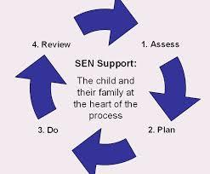
All SEN support at Chigwell Row Infants School, takes the form of a four-part cycle through which earlier decisions and actions are revisited and reviewed with a growing understanding of the pupil’s needs and of what supports the pupil in making good progress and securing good outcomes.

The child and family are at the heart of the Assess, Plan, Do, Review cycle. Pupil’s and Parent’s voice’s, aspirations and preferences are considered
· Assessments of what the pupil can do are outlined
· Planned outcome(s) (achievable and measurable) that they are working toward are written
· Support / provision that will be put in place for them to achieve this outcome
· Review of how far this outcome has been met with suggested next steps is added at the review.

Education Health Care Plan (EHCP, formerly a Statement of Special Educational
Needs):
EHCPs are for children with a high level of need, where the need can no longer be met at SEN Support. Before a school can support an application for an EHCP, it needs to evidence the cycles of ‘assess, plan, do and review’ though its own graduated approach to SEN. Reference would need to be made to the Local Offer (for Essex) and the Provision Guidance within it. The school would normally access advice and guidance through visiting specialists to the school to support in meeting the needs of the child under SEN support, prior to applying for an EHCP. Further detailed information about the EHCP requirements and processes are outlined in the local offer for Essex website. (See links at the end of the policy.)
Where a child has an Education and Health Care Plan, as a school we work closely with the child and family to ensure that we enable the child to enjoy and achieve to their full potential, working with the guidance and support that the document provides. It is essential that the child’s family is fully supporting the child and school where an EHC Needs Assessment application is needed.

Roles and Responsibilities

SEN Governor is responsible for supporting the school to monitor, evaluate and develop quality and impact of provision for pupils with SEN across the school.

Head Teacher is responsible for the day to day management of all aspects of the school, including the provision for pupils with SEND.

Special Educational Needs Co-ordinator (SENCO) is responsible for:
- Coordinating provision for children with SEN and developing the school’s SEN policy.
- Ensuring parents are involved in supporting their children’s learning.
- Keeping parents informed about the range and level of support offered to their child.
- Including parents/carers in reviewing how their child is doing.
- Using a range of agencies outside of school who can offer advice and support to help pupils overcome difficulties.
- Providing specialist advice and facilitating training to ensure all staff are skilled and confident about meeting a range of needs.
- Supporting teachers’ planning for differentiation which takes into account individual pupil needs and requirements. Differentiation will be planned by teachers in a range of ways to ensure that pupils can experience success and challenge in their learning.

Class Teacher is responsible for:
- All pupils’ learning, progress and development.
- Differentiation i.e. adapting and refining the curriculum to respond to the strengths and needs of any pupil with SEND in their class.
- Checking on the progress of all children and identifying, planning and delivering additional support.
- Contributing to devising personalised learning plans, where appropriate, to focus on next steps required to improve a child’s learning.
- Seeking and acting on support (e.g. from the SENCO, Subject Coordinators, Key Stage Leaders) to ensure quality first teaching and differentiation are in place in their class for pupils with SEND.
- Assessing and reviewing the impact of targeted interventions.

Learning Support Assistant (LSA):
An LSA sometimes works with the class and supports the children across the ability groups of the class. A minority of LSAs are assigned to work with a child that has significant needs. They will be the ‘supporting LSA’, not the child’s ‘1:1 LSA’.

As part of their roles to support children LSAs will:

- Support an individual child they have ‘been assigned to’ in various ways – individual sessions, within group learning sessions, supporting them in the whole class – directly or by providing ‘hover support’ where they help prepare the child for starting an activity and then check-in with the child throughout the lesson.
- Support and enable the learning of children, following the guidance of the class teacher / class teacher’s planning
- Deliver a range of ‘short-burst’ intervention and support programmes which will move learning / learning behaviours or other areas of need forward.
- Share information with the Class Teacher and SENCO.
- Support and deliver ‘interventions’ in the classroom whenever possible so that the child they are supporting has full access to the curriculum.

For any individual child with SEND, much of a supporting LSA’s role will be about helping the child to be an independent learner and to develop their social skills. This cannot be done if the LSA is beside the child 100% of the time. Obviously, there are exceptions to this i.e. where a child’s severely high needs are around being kept safe and they are unable to access learning without full support.

Staff Expertise: Training, as and when needed, is in place to ensure that teachers and learning support staff have the appropriate skills and knowledge in areas that will improve their teaching and support of children with SEND. Our SENCO has good knowledge of current local and national initiatives and policies that support pupils with a range of different needs. The SENCO also works with local SENCOs in the Epping Forest Schools Partnership Trust (MAT) and this group has access to advice, training an in-school support from an Educational Psychologist who is employed by the MAT. The SENCO is also part of the Essex County Council SENCO Cluster group. She is able to draw on advice and support from Essex SEND professionals.

Tracking: We assess learners continuously in order to track progress and make any necessary interventions. Children with One Plans or EHCPs have their progress monitored and new targets are introduced as needed. Teachers and LSAs meet termly (and more often if needed) with the SENCO to discuss children’s progress.

Our Partnerships: The school is a member of Epping Forest Schools Partnership Trust which provides a network of support and access to a range of resources and professional advice for children with SEND.
The school works closely with a range of professionals for specific needs, including:
- School Inclusion Partner
- School Nurse
- Physiotherapist
- Speech and Language Therapists
- Occupational Therapists
- Educational Psychologist (both Essex and EFSPT Educational Psychologist)
- Play Therapist
- Counsellor
- Music Therapist
- Specialist Teacher Teams
- EWMHS (Emotional Wellbeing & Mental Health Services)
- SENDOPs (SEND Operations)

Signposting: The SEND Policy is available on the school’s website, or we can provide copies on request.
www.chigwellrowinfants.com

Essex Local Offer is the comprehensive website for families, signposting you to many local services that can support you with your child’s SEND needs. For information on the Essex Local Offer, please visit Essex Local Offer

The Essex SEND ‘Information, Advice and Support Service’ (SENDIASS) can also offer information, support and impartial advice to parents of children with SEND. They can be contacted on 0333 013 8913. Email send.iass@essex.gov.uk
The special educational needs coordinator, (SENCO) Mrs L. Webb can be contacted via
e-mail or the school phone number, senco@chigwellrow.essex.sch.uk

If you still feel that you have further questions or concerns, you are able to contact the Headteacher, Ms Amy Dowling.

